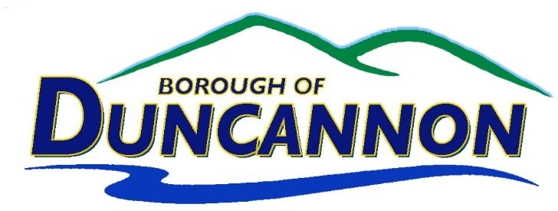

Revitalization Committee Meeting Agenda

Tuesday, October 14, 2025 • 7:00 PM

I. Call to Order – Joseph Misner- Chairman
II. Public Comment
III. New Business
- Any Issues Presented to the Committee.
- Changes to Square Parking
- Codes Enforcement recommendations for Dangerous/Dilapidate or Public Nuisance
IV. Unfinished Business
V. Next Meeting: The next regular business meeting of the Revitalization Committee will be Tuesday, November 11, 2025 at 7:00P.M.
THIS MEETING MAY BE RECORDED
Please turn off all cellular phones & pagers during the meeting

Mission Statement of the Duncannon Borough Council
The mission of the Duncannon Borough Council is to provide the necessary services to protect the health, safety, welfare, environment, and quality of life of our citizens, consistent with the community’s values and priorities.

The mission is accomplished by encouraging citizen involvement preserving the Borough’s fiscal stability, traditional values, and unity of our peoples through implementation of effective and efficient government programs, consensus building, managing the Borough’s natural culture and historic resources, planning for the future, and representing citizens’ needs and desires to other levels of government.

